

**HCENext**

NVIDIA GPU Cloud – Core Installation As-Built Document

Prepared by: Sonali Das and Saumya Tripathi

Technology Consultant

Date Prepared: March 22, 2023

Version: 1.0

Document Information

|  |  |  |  |
| --- | --- | --- | --- |
| Project name | NGC | | |
| Prepared by | Sonali Das  Saumya Tripathi | Document version number | 1.0 |
| Title | Technical Consultant | Document version date |  |

|  |  |  |  |
| --- | --- | --- | --- |
| **To** | **Action\*** | **Due date** | **Phone/Fax/Email** |
| Abhishek Behera | Review |  | behera@hpe.com |
| Ankur Gupta | Review |  | ankurg@hpe.com |
|  |  |  |  |

*\* Action Types: Approve, Review, Inform, File, Action Required, Attend Meeting, Other (please specify)*

Version History

| Ver. No. | Ver. Date | Created By | Description |
| --- | --- | --- | --- |
| 1.0 |  |  | Initial Draft |
|  |  |  |  |
|  |  |  |  |
|  |  |  |  |

Table of Contents

1. Introduction 4

1.1. Purpose 4

1.2. NGC Overview 4

1.3. Installation Pre-requisites 4

2. Installation and Configuration Steps 5

1. Introduction
   1. Purpose

Purpose of this document is to describe core installation of NVIDIA container runtime on HPE DL 380 Gen10 server embedded with NVIDIA GPUs.

* 1. NGC – Core Service Overview

NVIDIA GPU Cloud is a container registry created out of HPE Servers and NVDIA GPUs. The purpose is to add plugins to the infrastructure developed and use NVDIA’s container runtime.

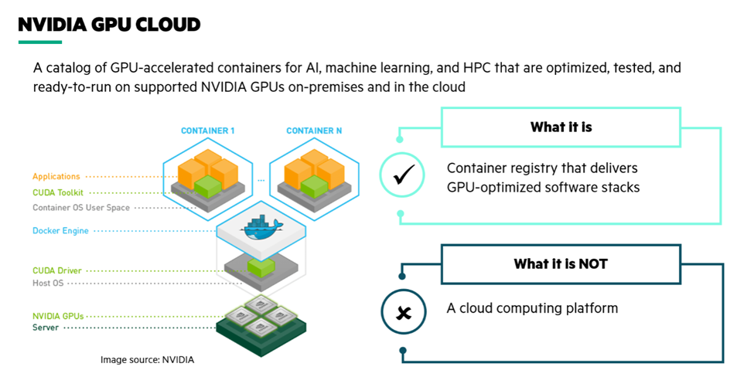

Service Scope: Installation + Configuration + Validation of GPU-enabled and NGC Ready Infra

Service Type: Core (Container Platform Installation and Configuration)

* 1. Installation Pre-requisites
     1. OS Version
     2. Prerequisites packages - gcc,kernel headers and dev packages
     3. No NVDIA/CUDA previously installed
     4. All GPUs are visible and CUDA capable
     5. Network connectivity to all the servers within scope & proxy should be configured
     6. SSH access to the serves with required privileges (root or sudo configured)
     7. Conncetivity to reqd. Repositories

**SERVER ACQUIRED:**

HPE Proliant DL 380 Gen10 with dual Intel(R) Xeon(R) Gold 5218 CPU @ 2.30GHz processor, 64GB memory, 900GB local disk space, and with two NVIDIA Tesla T4 cards.

Proxy Server IP: 10.154.248.91 port 8080

Hostname: DL380G10N4U17

IP: 10.55.175.15

Netmask : 255.255.248.0

Gateway: 10.55.175.254

Primary DNS: 10.154.248.9

Secondary DNS: 10.154.248.10

1. Installation and Configuration Steps

|  |  |
| --- | --- |
| 1. | Base OS Installation |
| 2. | Installation of Pre-requisite packages |
| 3. | Setting up NVIDIA CUDA drivers |
| 4. | Docker Installation |
| 5. | NVIDIA Container Toolkit |

* 1. **Base OS Installation (Ubuntu 22.04):**
     1. Login as IRC or HTML5 remote console and mount the iso image from local files and do cold reboot after mounting the iso image.
     2. Press F11 to select “Boot Menu”. Select “try and install Ubuntu”.
     3. Follow the instructions shown to install Ubuntu.
     4. During partitioning scheme, following partitions have been given:

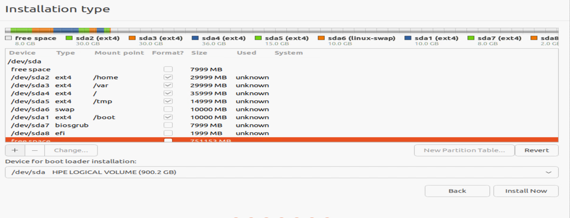

* + 1. During user assignment, following entries have been made:

Username: user

Password: user@123

* + 1. Proceed with installation.
    2. Setting static IP and proxy details through GUI and in /etc/network/interfaces.
    3. Setting proxy to access apt repositories:

Go to /etc/apt/apt.conf.d and create a file called “proxy.conf”. Add the shown lines inside the file.

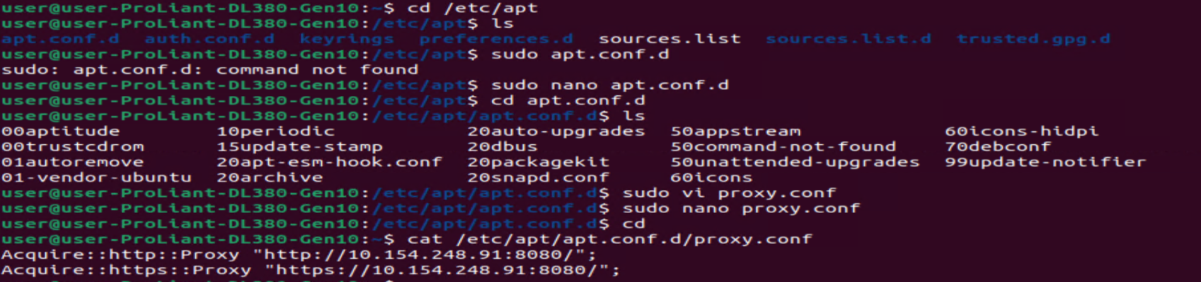

* 1. **Installation of Pre-requisite packages:**
     1. Validating OS version:

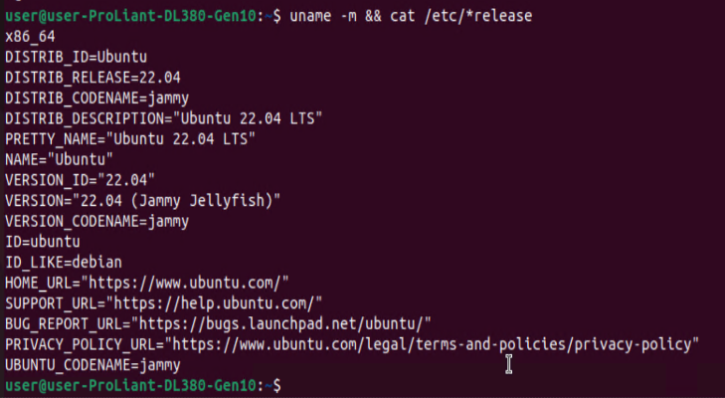

* + 1. Validating kernel version:



* + 1. Verifying whether the CUDA drivers are pre-installed or not:

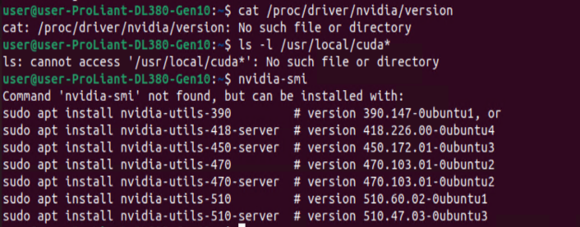

* + 1. Installing gcc and validating the version:



* + 1. Verifying if GPUs are installed and enabled:



* 1. **Setting up NVIDIA CUDA drivers:**
     1. wget https://developer.download.nvidia.com/compute/cuda/repos/ubuntu2204/x86_64/cuda-ubuntu2204.pin

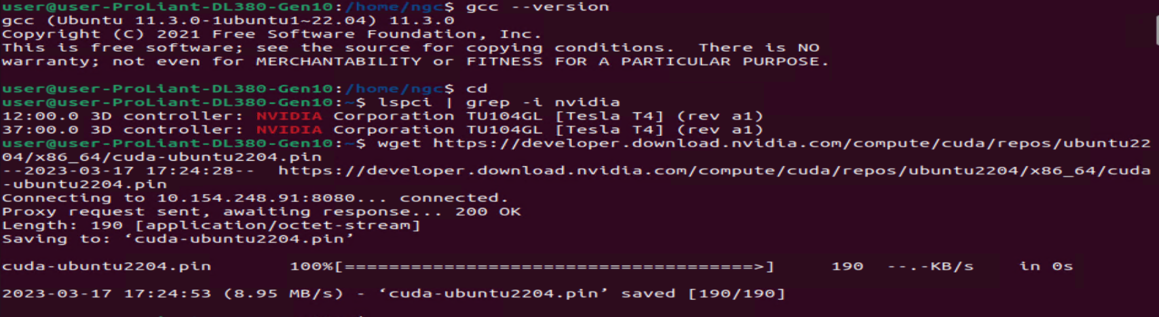

* + 1. sudo mv cuda-ubuntu2204.pin /etc/apt/preferences.d/cuda-repository-pin-600
    2. wget https://developer.download.nvidia.com/compute/cuda/12.1.0/local_installers/cuda-repo-ubuntu2204-12-1-local_12.1.0-530.30.02-1_amd64.deb

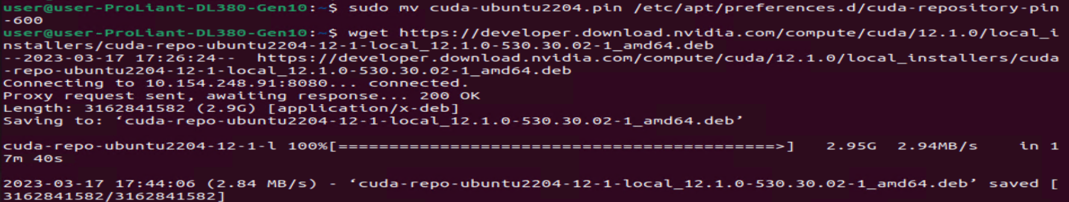

* + 1. sudo cp /var/cuda-repo-ubuntu2204-12-1-local/cuda-*-keyring.gpg /usr/share/keyrings/
    2. sudo dpkg -i cuda-repo-ubuntu2204-12-1-local_12.1.0-530.30.02-1_amd64.deb
    3. sudo apt-get update

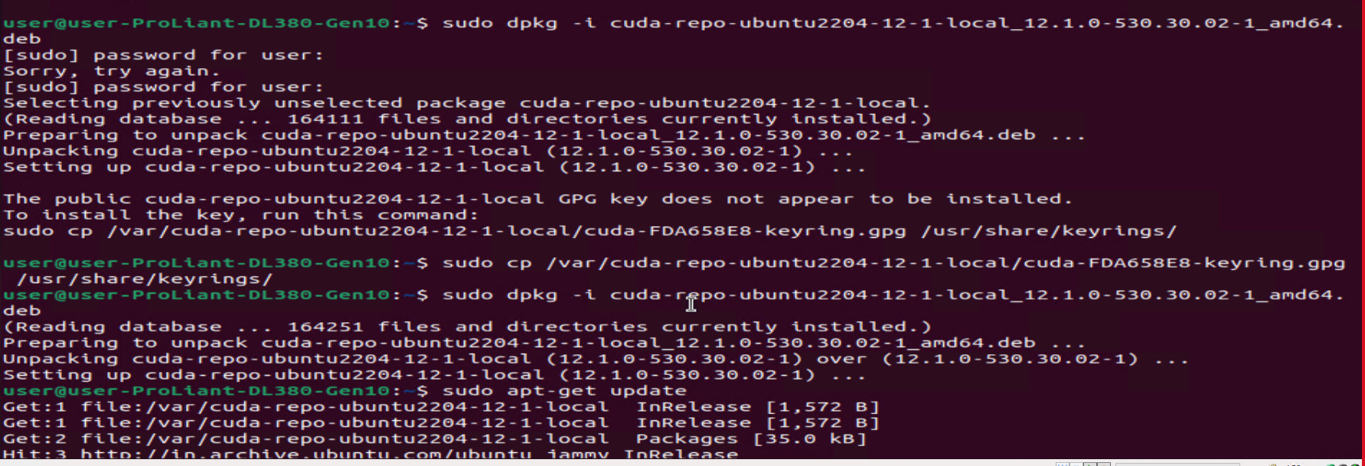

* + 1. sudo apt-get -y install cuda

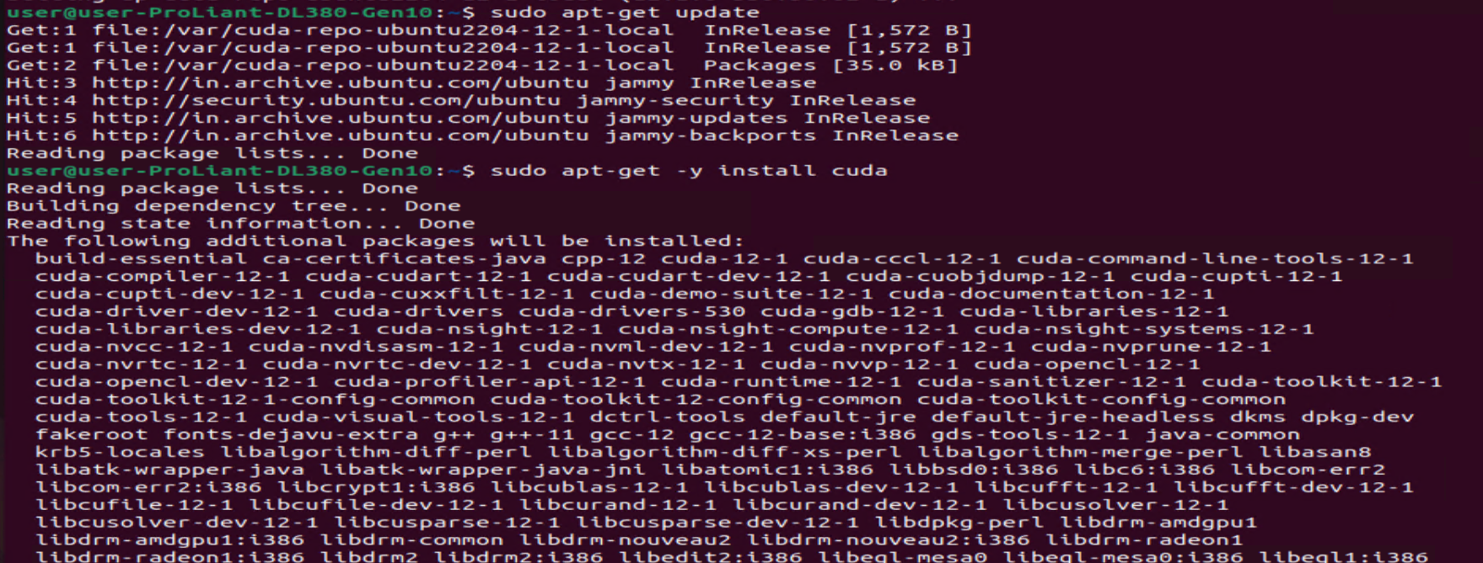

* + 1. Reboot the server once the cuda driver installation is completed.

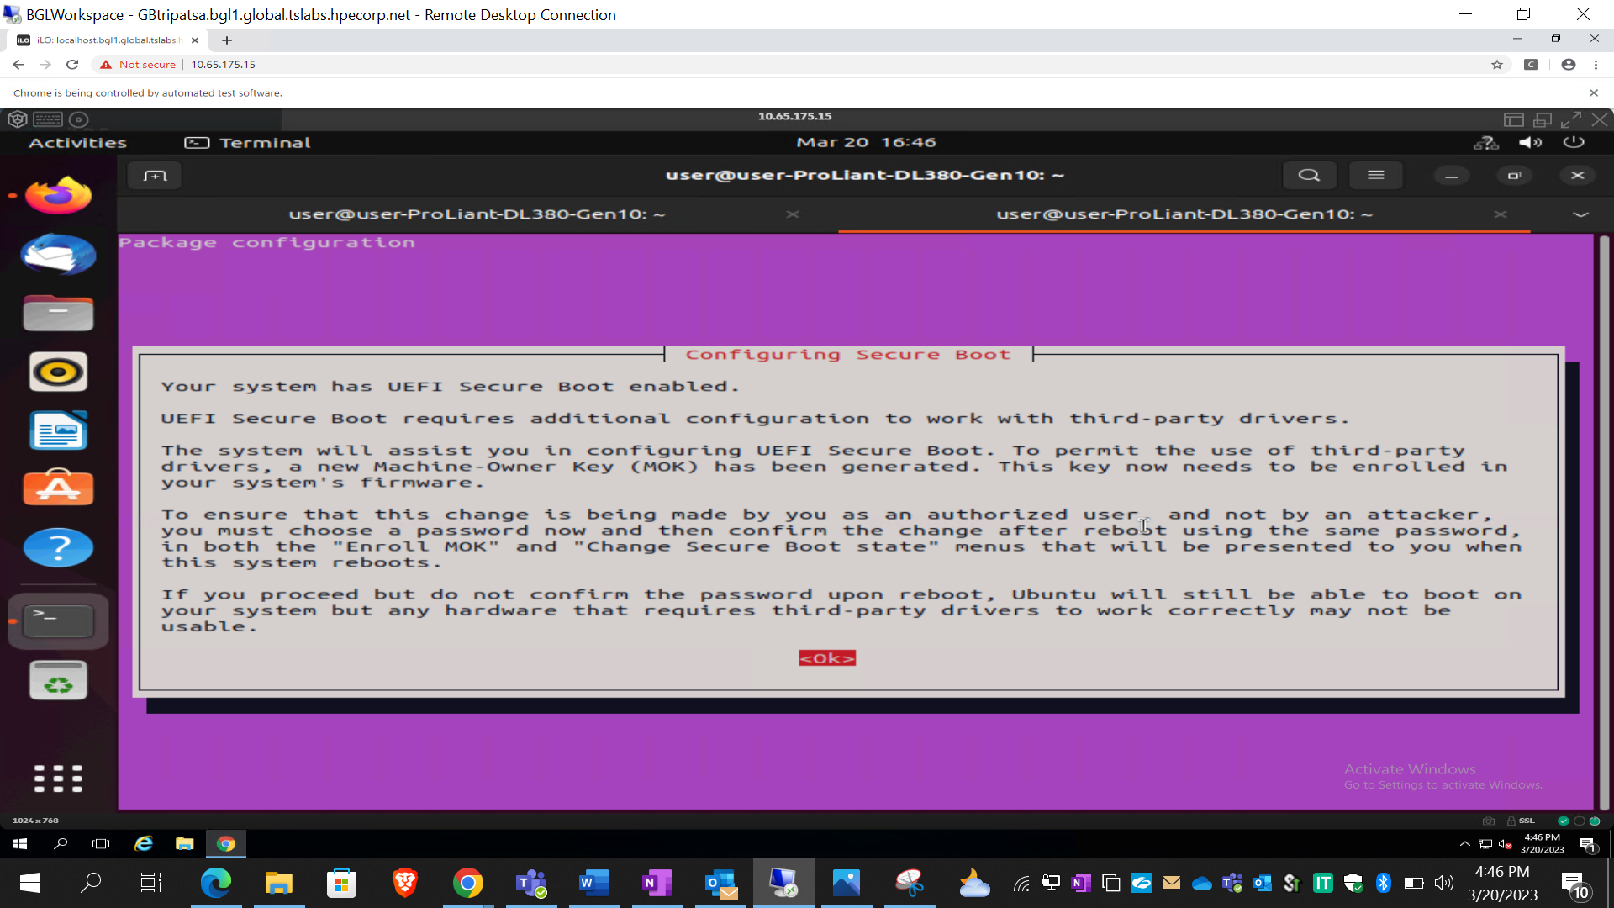

* + 1. Select “Enroll MOK” and enter the password used after cuda installation.
    2. Reboot and select F9 “System Utilities” this time. Go to system configuration > bios (RBSU) > server security > secure boot settings. Select disable for attempt secure boot and save and exit. Reboot after this step.

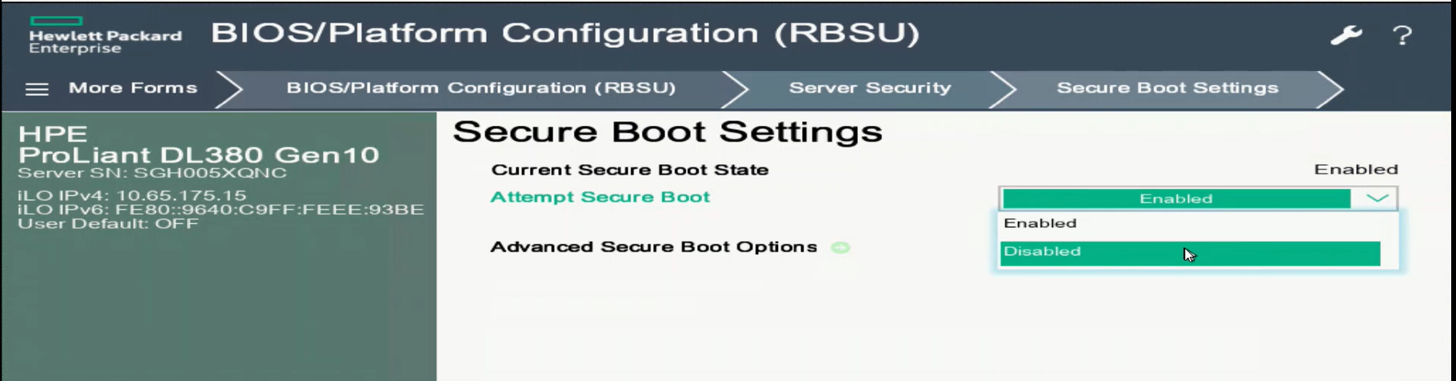

* + 1. Login and enter the command “nvidia-smi” to see status of the drivers installed.

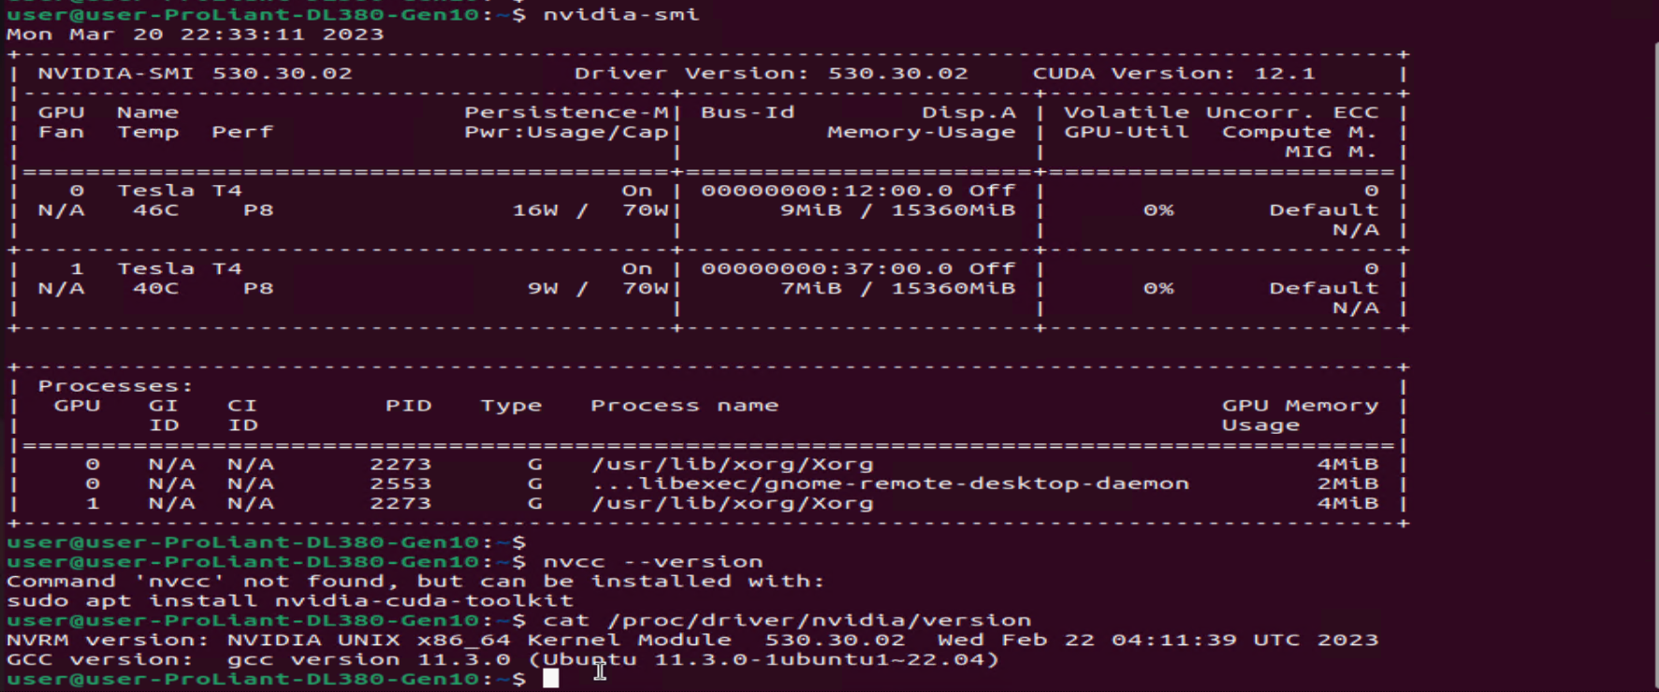

**Reference:** <https://developer.nvidia.com/cuda-downloads?target_os=Linux&target_arch=x86_64&Distribution=Ubuntu&target_version=22.04&target_type=deb_local>

* 1. **Docker Installation:**
     1. Configuring proxy for the docker environment.

1. Navigate to the location cd /etc/systemd/system
2. Create a folder with the name “docker.service.d”(Command: mkdir docker.service.d)
3. Create a new file with the name http-proxy.conf
4. Copy the below content and save the configuration.

[Service]

Environment="https_proxy=http://10.154.248.91:8080/""NO_PROXY=localhost,127.0.0.0/8,10.0.0.0/8,10.30.0 .0/16"

Environment="http_proxy=http://10.154.248.91:8080/"



* + 1. Install docker engine according to official documentations:

1. sudo apt-get update
2. sudo apt-get install ca-certificates curl gnupg lsb-release
3. sudo mkdir -m 0755 -p /etc/apt/keyrings
4. curl -fsSL https://download.docker.com/linux/ubuntu/gpg | sudo gpg --dearmor -o /etc/apt/keyrings/docker.gpg
5. echo "deb [arch=$(dpkg --print-architecture) signed-by=/etc/apt/keyrings/docker.gpg] https://download.docker.com/linux/ubuntu $(lsb_release -cs) stable" | sudo tee /etc/apt/sources.list.d/docker.list > /dev/null
6. sudo apt-get update
7. sudo apt-get install docker-ce docker-ce-cli containerd.io docker-buildx-plugin docker-compose-plugin
   * 1. Add user to docker group and restart docker:
8. sudo usermod -aG docker $USER
9. sudo systemctl restart docker
10. sudo systemctl daemon-reload
    * 1. Verify by running “docker version” and pulling a hello-world image:

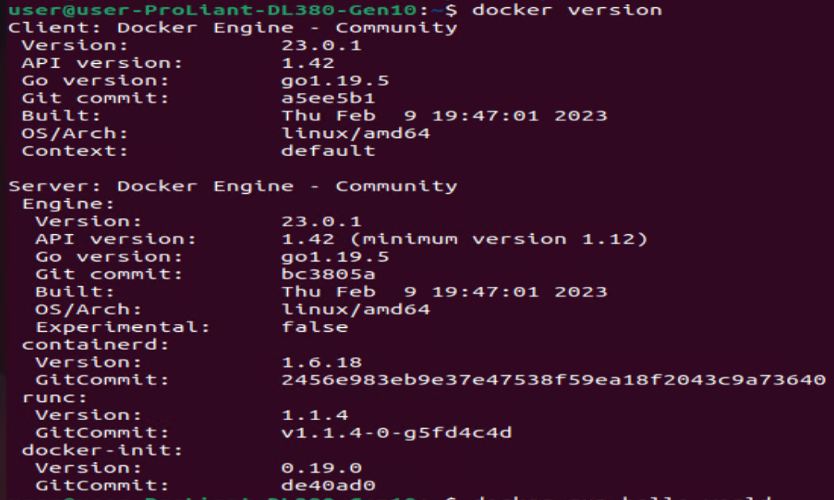

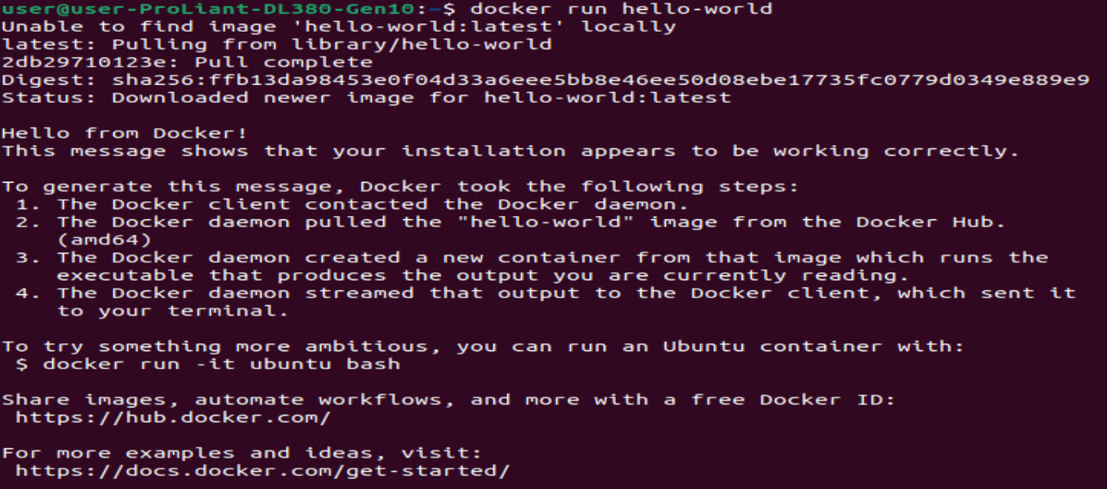

**Reference:** <https://docs.docker.com/engine/install/ubuntu/>

* 1. **NVIDIA Container Toolkit:**
     1. Setup the stable repository and the GPG key:

distribution=$(. /etc/os-release;echo $ID$VERSION_ID) \

&& curl -s -L https://nvidia.github.io/nvidia-docker/gpgkey | sudo apt-key add - \

&& curl -s -L https://nvidia.github.io/nvidia-docker/$distribution/nvidia-docker.list | sudo tee /etc/apt/sources.list.d/nvidia-docker.list

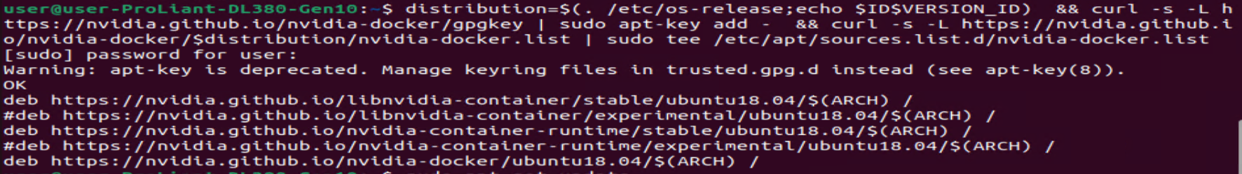

* + 1. Install the NVIDIA runtime packages:

sudo apt-get update && sudo apt-get install -y nvidia-docker2

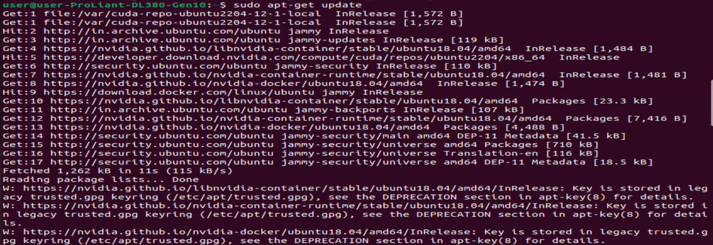

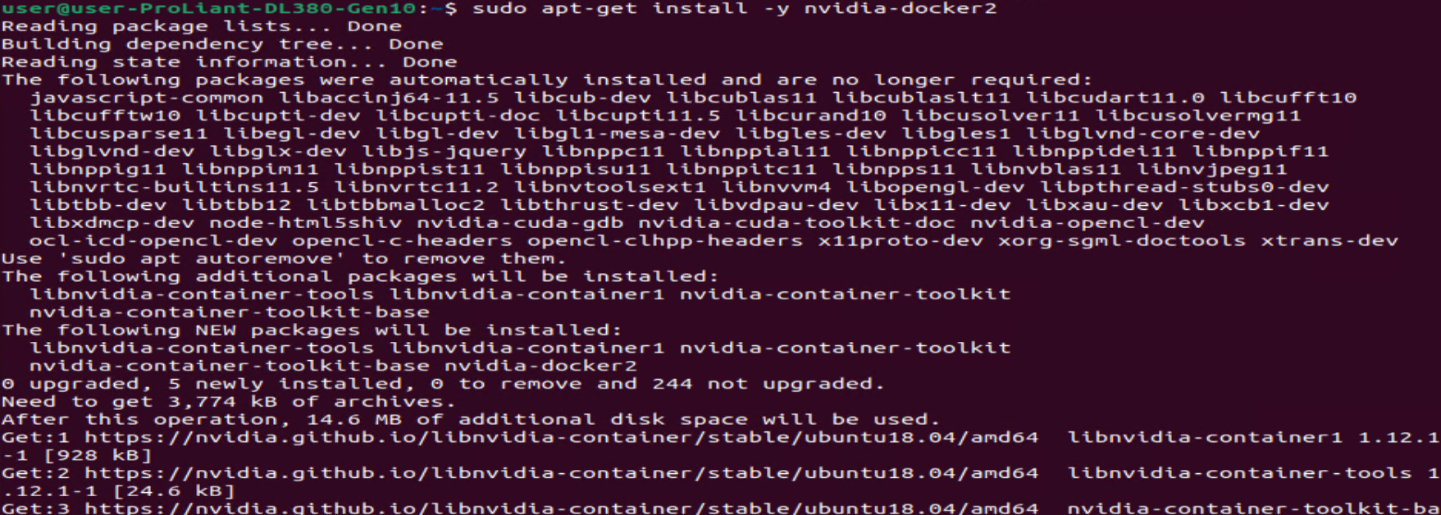

* + 1. Make changes in the Docker Daemon Config file by setting the default runtime:

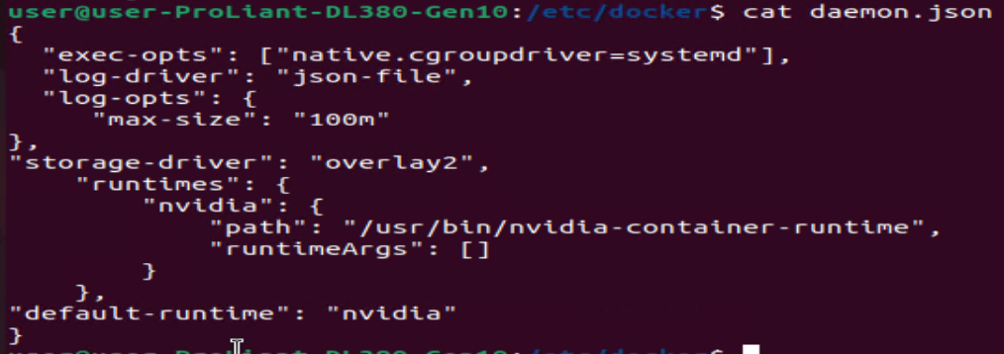

* + 1. Post these changes restart Daemon and Docker services using below commands:

1. systemctl daemon-reload
2. systemctl restart docker



* 1. **Running sample docker image:**
     1. Run “docker pull nvcr.io/nvidia/tensorflow:20.11-tf1-py3”

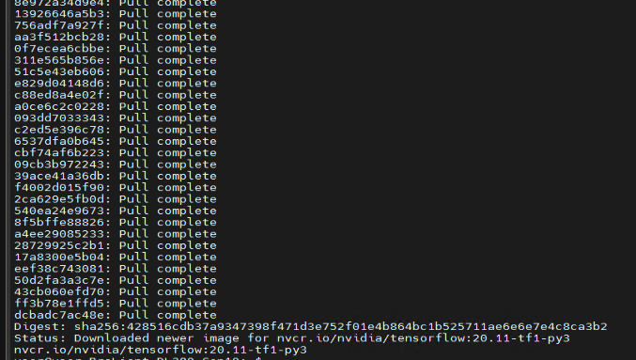

* + 1. Run “docker run --gpus all -it --shm-size=1g --ulimit memlock=-1 --ulimit stack=67108864 --rm nvcr.io/nvidia/tensorflow:20.11-tf1-py3”

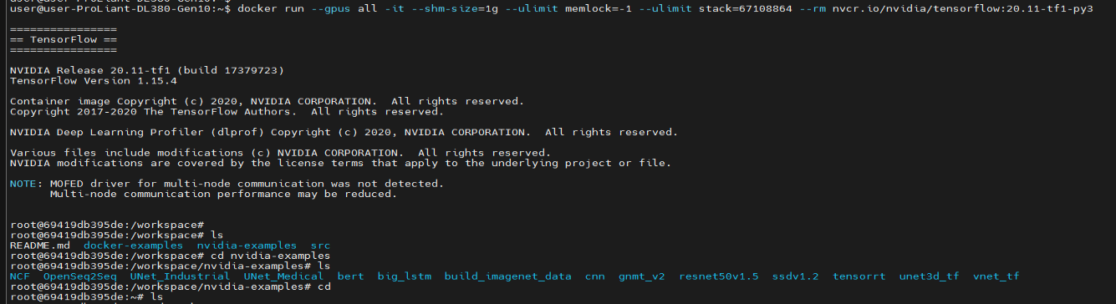

* + 1. Go to given directory: cd /workspace/nvidia-examples/cnn

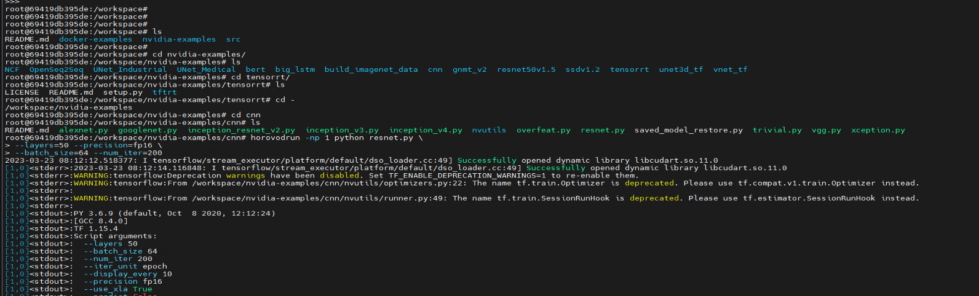

* + 1. Run the python file named as “resnet.py”:

horovodrun -np 1 python resnet.py \

--layers=50 --precision=fp16 \

--batch_size=64 --num_iter=200

On another tab, run “watch nvidia-smi” to see live status of the power consumption and temperature change in gpus.

With 1 gpu: set np=1

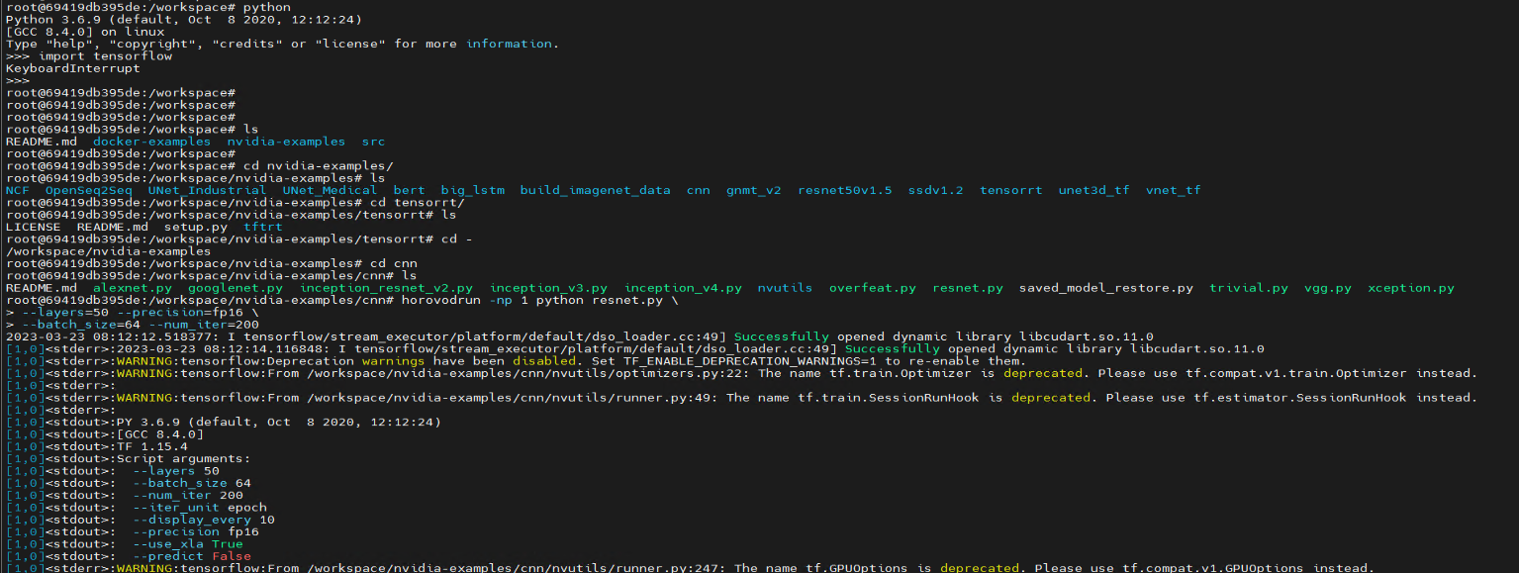

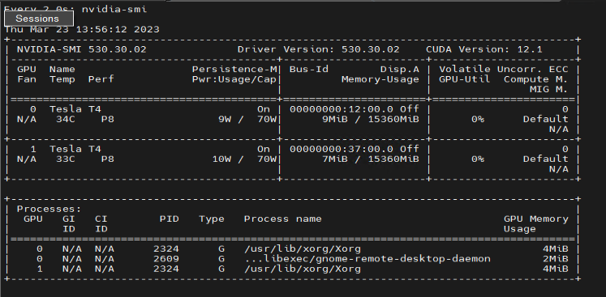

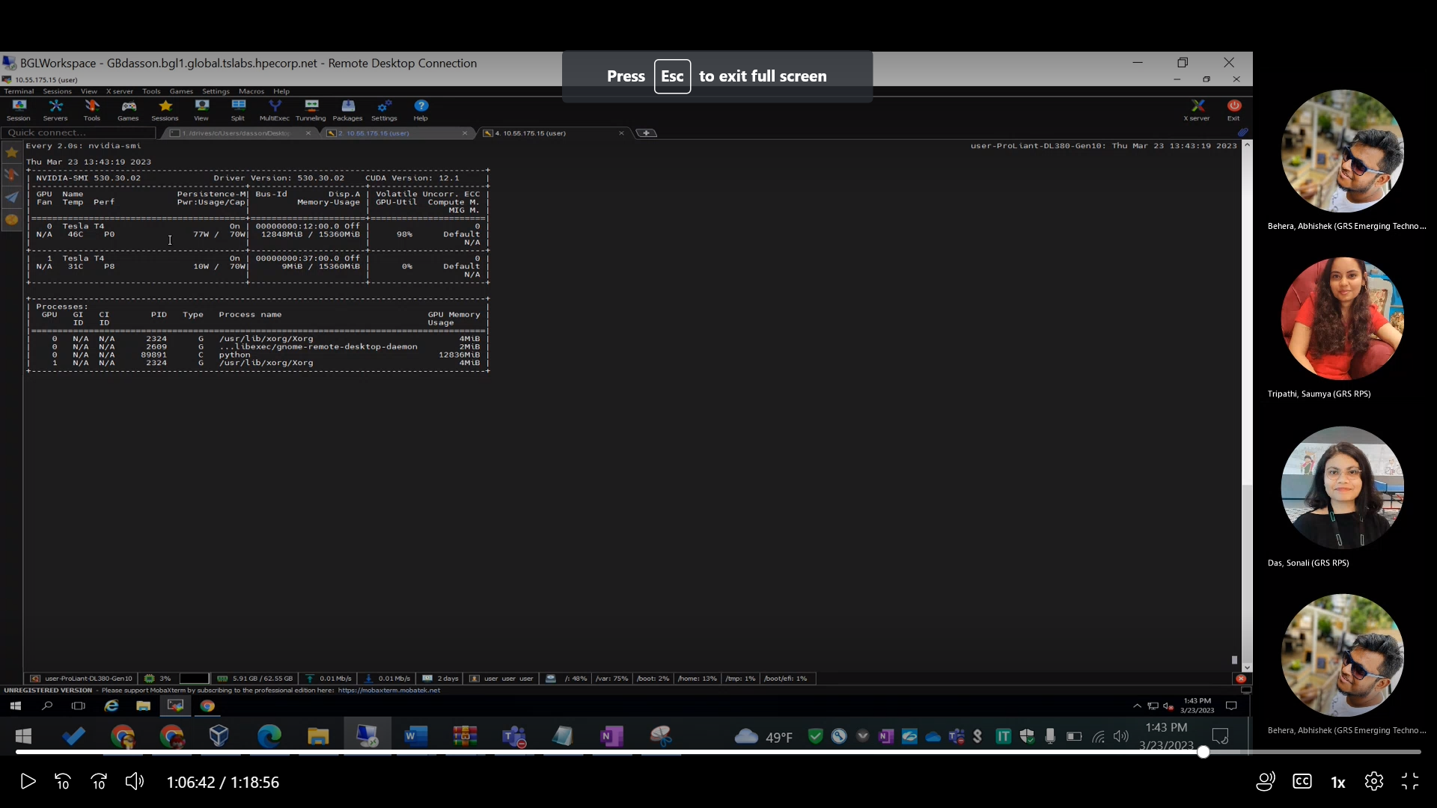

With 2 gpus: set np=2

